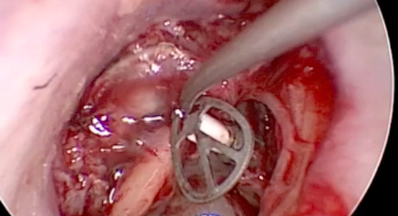

Greenlane Temporal Bone Lab – Basement of the Greenlane Clinical Building 4.

$2000 for the course and lunches

0211128276

Ent.auz@gmail.com

RSVP: Michelle Wong

# Thursday-Friday 4-5th July 2019

## Limited Numbers. SET takes priority

2019 Greenlane Registrar Temporal Bone Course